Basic Elements of Layered Architecture
- Service: It is a set of actions that a layer provides to the higher layer.
- Protocol: It defines a set of rules that a layer uses to exchange the information with peer entity. These rules mainly concern about both the contents and order of the messages used.
- Interface: It is a way through which the message is transferred from one layer to another layer.

Features of Protocol Layering
- It decomposes the problem of building a network into more manageable components.

It provides a more modular design.

Principles of Protocol Layering
- The first principle dictates that if we want bidirectional communication, we need to make each layer so that it is able to perform two opposite tasks, one in each direction.
- The second principle that we need to follow in protocol layering is that the two objects under each layer at both sites should be identical.

Protocol Graph
  - The set of protocols that make up a network system is called a protocol graph.
  - The nodes of the graph correspond to protocols, and the edges represent a dependence relation.
  - For example, the Figure below illustrates a protocol graph consists of protocols RRP (Request/Reply Protocol) and MSP (Message Stream Protocol) implement two different types of process-to-process channels, and both depend on the HHP (Host-to- Host Protocol) which provides a host-to-host connectivity service
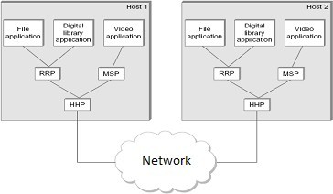

OSI MODEL
- OSI stands for Open System Interconnection.
- It is a reference model that describes how information from a software application in one computer moves through a physical medium to the software application in another computer.
- OSI consists of seven layers, and each layer performs a particular network function.
- OSI model was developed by the International Organization for Standardization (ISO) in 1984.
- It is considered as an architectural model for the inter-computer communications.
- OSI model divides the whole task into seven smaller and manageable tasks. Each layer is assigned a particular task.
- Each layer is self-contained, so that task assigned to each layer can be performed independently.
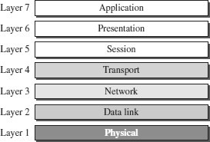

ORGANIZATION OF THE OSI LAYERS

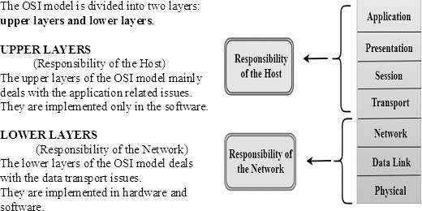

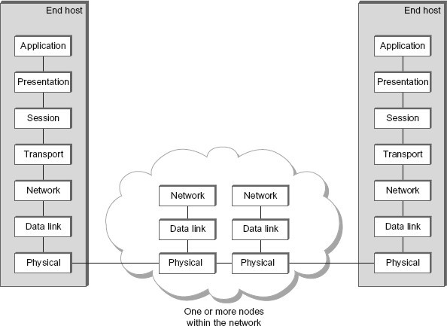

FUNCTIONS OF THE OSI LAYERS

PHYSICAL LAYER
The physical layer coordinates the functions required to transmit a bit stream over a physical medium.
The physical layer is concerned with the following functions:
  - Physical characteristics of interfaces and media - The physical layer defines the characteristics of the interface between the devices and the transmission medium.
  - Representation of bits - To transmit the stream of bits, it must be encoded to signals. The physical layer defines the type of encoding.
  - Signals: It determines the type of the signal used for transmitting the information.
  - Data Rate or Transmission rate - The number of bits sent each second –is also defined by the physical layer.
  - Synchronization of bits - The sender and receiver must be synchronized at the bit level. Their clocks must be synchronized.
  - Line Configuration - In a point-to-point configuration, two devices are connected together through a dedicated link. In a multipoint configuration, a link is shared between several devices.
  - Physical Topology - The physical topology defines how devices are connected to make a network. Devices can be connected using a mesh, bus, star or ring topology.
  - Transmission Mode - The physical layer also defines the direction of transmission between two devices: simplex, half-duplex or full-duplex.

DATA LINK LAYER
It is responsible for transmitting frames from one node to the next node. The other responsibilities of this layer are
  - Framing - Divides the stream of bits received into data units called frames.
  - Physical addressing – If frames are to be distributed to different systems on the network , data link layer adds a header to the frame to define the sender and receiver.
  - Flow control- If the rate at which the data are absorbed by the receiver is less than the rate produced in the sender ,the Data link layer imposes a flow control mechanism.
  - Error control- Used for detecting and retransmitting damaged or lost frames and to prevent duplication of frames. This is achieved through a trailer added at the end of the frame.
  - Medium Access control -Used to determine which device has control over the link at any given time.

NETWORK LAYER
This layer is responsible for the delivery of packets from source to destination.
It determines the best path to move data from source to the destination based on the network conditions, the priority of service, and other factors.
The other responsibilities of this layer are
  - Logical addressing - If a packet passes the network boundary, we need another addressing system for source and destination called logical address. This addressing is used to identify the device on the internet.
  - Routing – Routing is the major component of the network layer, and it determines the best optimal path out of the multiple paths from source to the destination.

TRANSPORT LAYER
It is responsible for Process to Process delivery. That is responsible for source-to- destination (end-to-end) delivery of the entire message, It also ensures whether the message arrives in order or not.
The other responsibilities of this layer are
  - Port addressing / Service Point addressing - The header includes an address called port address / service point address. This layer gets the entire message to the correct process on that computer.
  - Segmentation and reassembly - The message is divided into segments and each segment is assigned a sequence number. These numbers are arranged correctly on the arrival side by this layer.
  - Connection control - This can either be connectionless or connection oriented.
    - The connectionless treats each segment as an individual packet and delivers to the destination.
    - The connection-oriented makes connection on the destination side before the delivery. After the delivery the termination will be terminated.
  - Flow control - The transport layer also responsible for flow control but it is performed end-to-end rather than across a single link.
  - Error Control - Error control is performed end-to-end rather than across the single link..

SESSION LAYER
This layer establishes, manages and terminates connections between applications. The other responsibilities of this layer are
  - Dialog control - Session layer acts as a dialog controller that creates a dialog between two processes or we can say that it allows the communication between two processes which can be either half-duplex or full-duplex.
  - Synchronization- Session layer adds some checkpoints when transmitting the data in a sequence. If some error occurs in the middle of the transmission of data, then the transmission will take place again from the checkpoint. This process is known as Synchronization and recovery.

PRESENTATION LAYER
It is concerned with the syntax and semantics of information exchanged between two systems.
The other responsibilities of this layer are
  - Translation – Different computers use different encoding system, this layer is responsible for interoperability between these different encoding methods. It will change the message into some common format.
  - Encryption and decryption-It means that sender transforms the original information to another form and sends the resulting message over the n/w. and vice versa.
  - Compression and expansion-Compression reduces the number of bits contained in the information particularly in text, audio and video.

APPLICATION LAYER
This layer enables the user to access the network. It handles issues such as network transparency, resource allocation, etc. This allows the user to log on to remote user.
The other responsibilities of this layer are
  - FTAM (File Transfer, Access, Management) - Allows user to access files in a remote host.
  - Mail services - Provides email forwarding and storage.
  - Directory services - Provides database sources to access information about various sources and objects.

TCP / IP PROTOCOL SUITE
- The TCP/IP architecture is also called as Internet architecture.
- It is developed by the US Defense Advanced Research Project Agency (DARPA) for its packet switched network (ARPANET).
- TCP/IP is a protocol suite used in the Internet today.
- It is a 4-layer model. The layers of TCP/IP are
- Application layer
- Transport Layer (TCP/UDP)
- Internet Layer
- Network Interface Layer
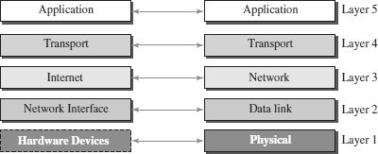

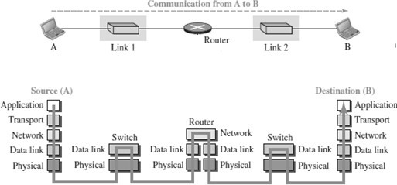

APPLICATION LAYER
- An application layer incorporates the function of top three OSI layers. An application layer is the topmost layer in the TCP/IP model.
- It is responsible for handling high-level protocols, issues of representation.
- This layer allows the user to interact with the application.
- When one application layer protocol wants to communicate with another application layer, it forwards its data to the transport layer.
- Protocols such as FTP, HTTP, SMTP, POP3, etc running in the application layer provides service to other program running on top of application layer

TRANSPORT LAYER
- The transport layer is responsible for the reliability, flow control, and correction of data which is being sent over the network.
- The two protocols used in the transport layer are User Datagram protocol and Transmission control protocol.
  - UDP – UDP provides connectionless service and end-to-end delivery of transmission. It is an unreliable protocol as it discovers the errors but not specify the error.
  - TCP – TCP provides a full transport layer services to applications. TCP is a reliable protocol as it detects the error and retransmits the damaged frames.

INTERNET LAYER
- The internet layer is the second layer of the TCP/IP model.
- An internet layer is also known as the network layer.
- The main responsibility of the internet layer is to send the packets from any network, and they arrive at the destination irrespective of the route they take.
- Internet layer handle the transfer of information across multiple networks through router and gateway .
- IP protocol is used in this layer, and it is the most significant part of the entire TCP/IP suite.

NETWORK INTERFACE LAYER
- The network interface layer is the lowest layer of the TCP/IP model.
- This layer is the combination of the Physical layer and Data Link layer defined in the OSI reference model.
- It defines how the data should be sent physically through the network.
- This layer is mainly responsible for the transmission of the data between two devices on the same network.
- The functions carried out by this layer are encapsulating the IP datagram into frames transmitted by the network and mapping of IP addresses into physical addresses.
- The protocols used by this layer are Ethernet, token ring, FDDI, X.25, frame relay.

COMPARISON - OSI MODEL AND TCP/IP MODEL
